**DOCUMENTATION**

Warning! We would recommend you to make a reskin to prevent  
problems with Google Play and App Store (game can be banned).  
  
You Can require Our Reskin Services as well from Staying away from the red zone of the playconsole And App Store Policies

Integration of side plugins is your own responsibility.

Support Can be given you In Current Issues.

All rights of the source code belong reserved by Markhor Studio Games. After purchase you will have the right to use it to create your own games and publish it on stores. Resale of the source code is prohibited.

**Tutorial Link:** [**https://youtu.be/yDu0hFxgMOo**](https://youtu.be/yDu0hFxgMOo)

**How to Start**

**1.**Download and Install the recommended Unity Version(2020.3.24f1) – **Download**  
**2.** Create a new Unity project.  
**3.** Change Ads ids(Check Below How to do)  
**4.** Reskin the Game(Check Below the Steps)  
**7.**Create More Objects(Add new Objects)  
**8.**Add More Levels(Add new Levels using editor)  
**9.** Build the apk file

**How to Integrate Your Own Ads ids**

**1.**Open Main Menu Scene(Assets/Resources/Scenes/mainmenu)  
**2.**Click on AdManager And Paste your New Ids

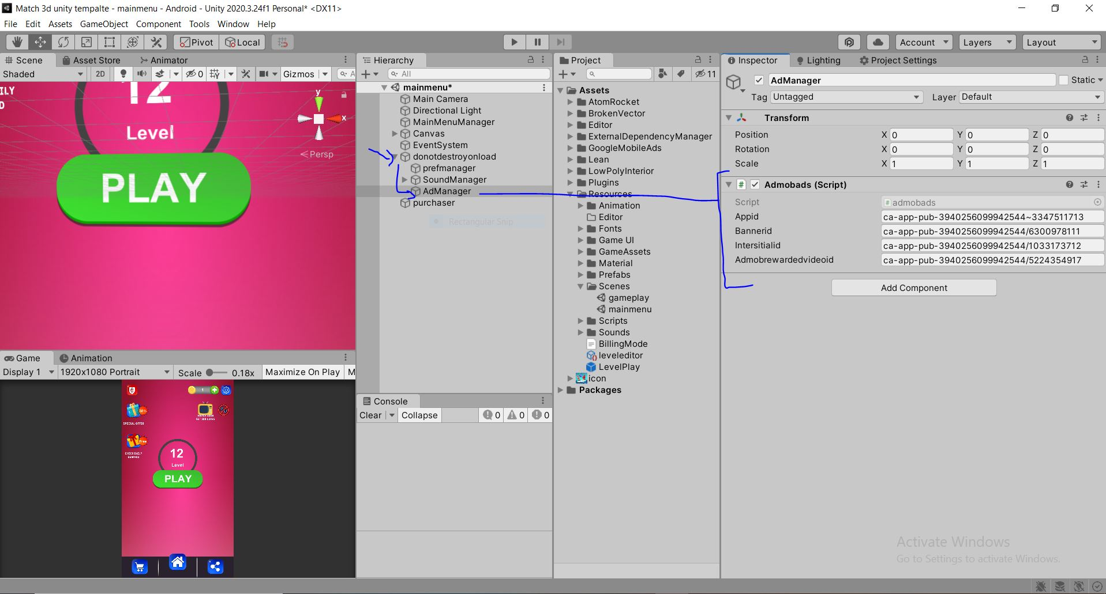

**3.**Must Replace your App id here as well  
  
  
**How to Make Inapp Ids Work**

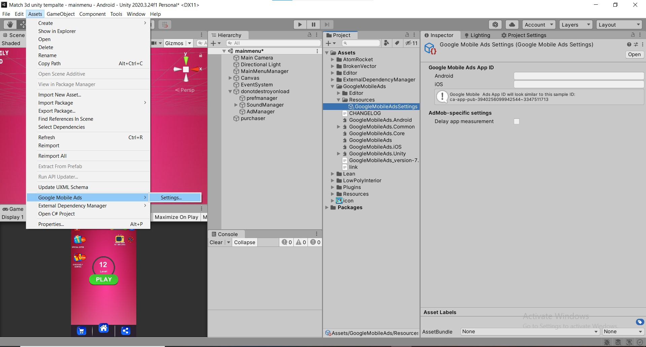

1.Click On Purchaser   
2.In Inspector you found different Inapp Purchases   
3.Modify Any Price And Assigning Values of Coins ,Hints And Time Freezes

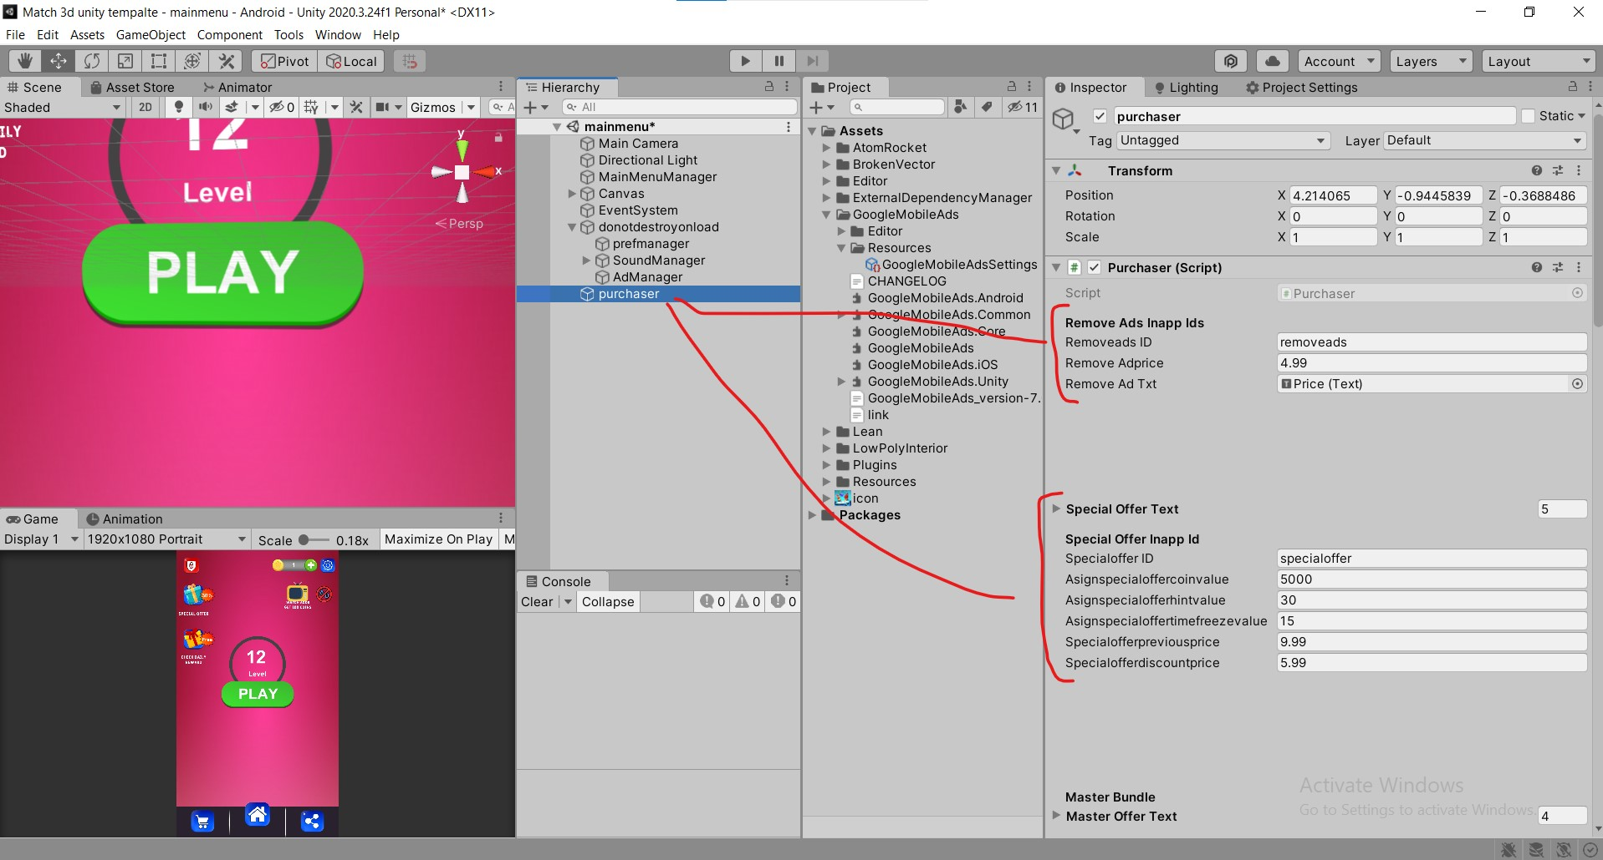

**How to Create Inapp Ids On Playconsole**Now after modifying you have to Copy ids and have to paste On playconsole to make this Work

**1.Open your Playconsole account  
2.Open the Game you Created  
3.You Only Able to Create Inapp Ids After you Uploaded Abb file to Playconsole  
4.Now Click Here to Open Inapp Screen And than click Create Product  
  
  
5.Copy from Unity Editor And Place Here  
6.Than Scroll down Click On Set Price  
7. And Than Set Price And Activate the Inapp After click on saving**

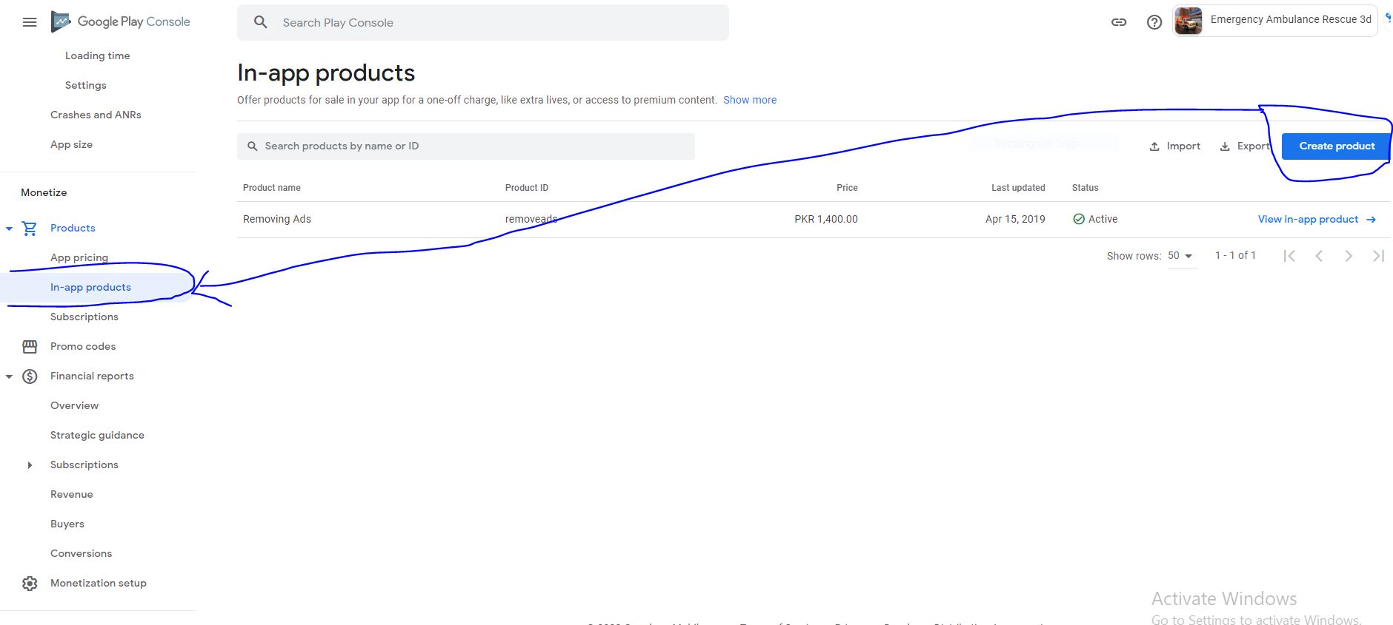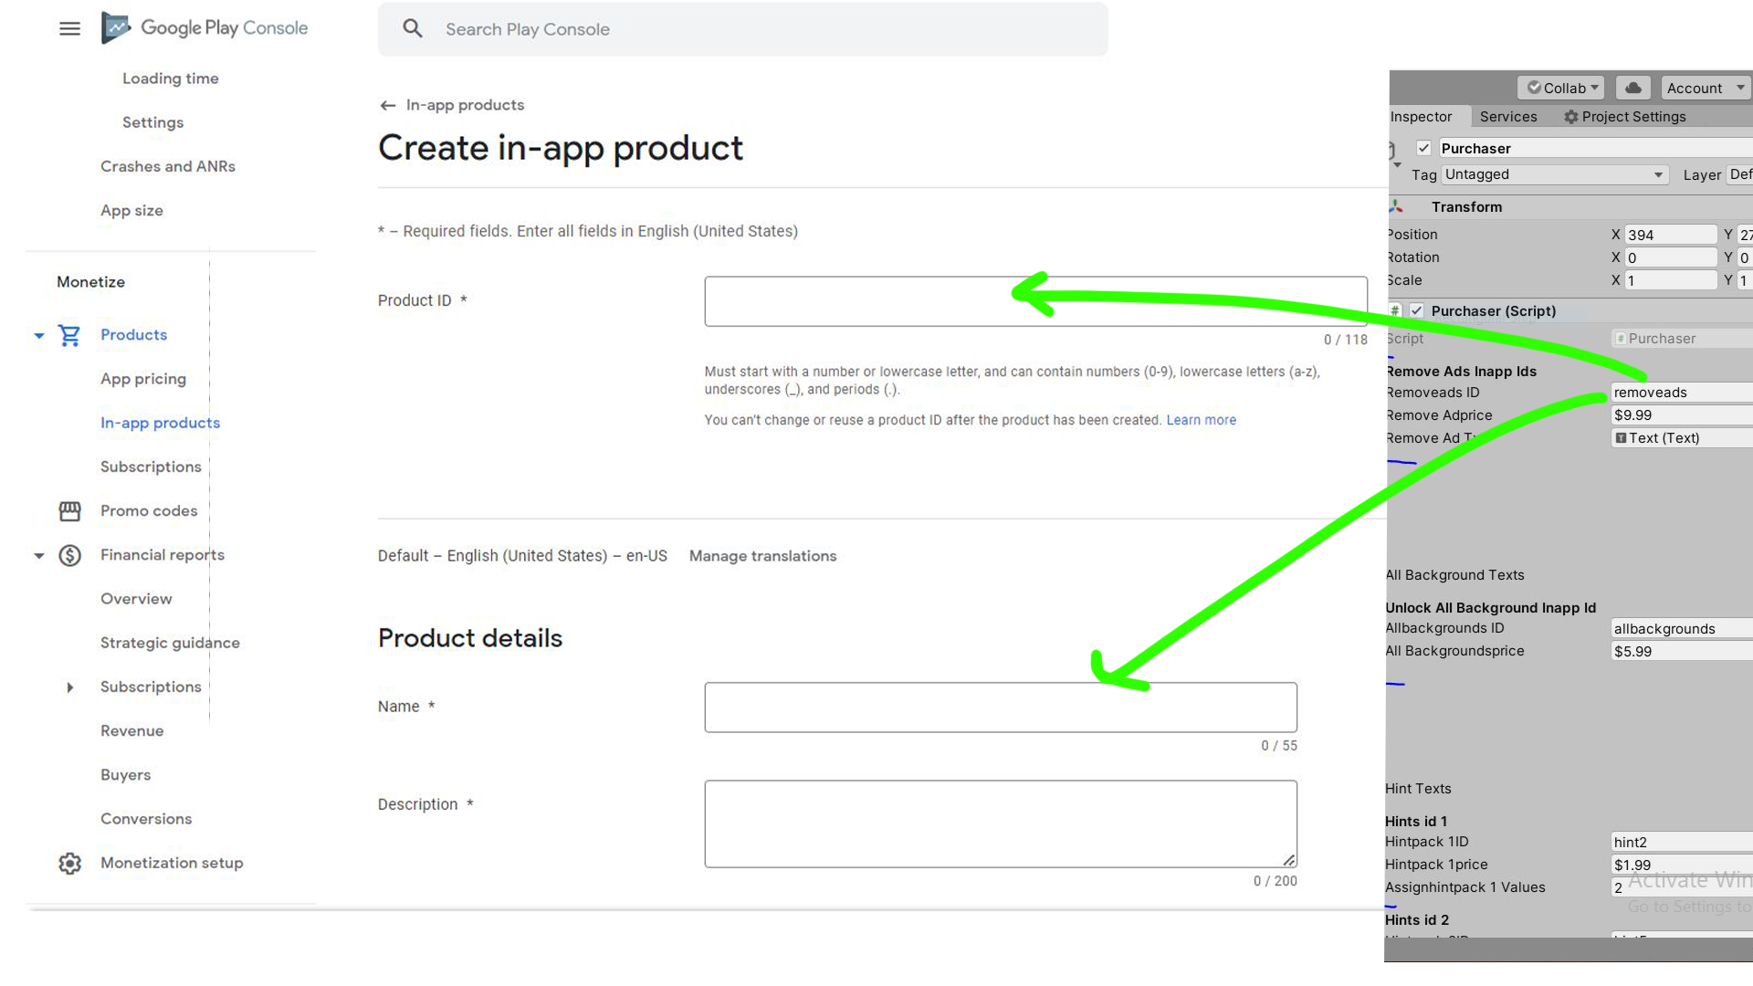

**How to Reskin the Game  
1.**Open UI folder And replace All the design files with your new design files

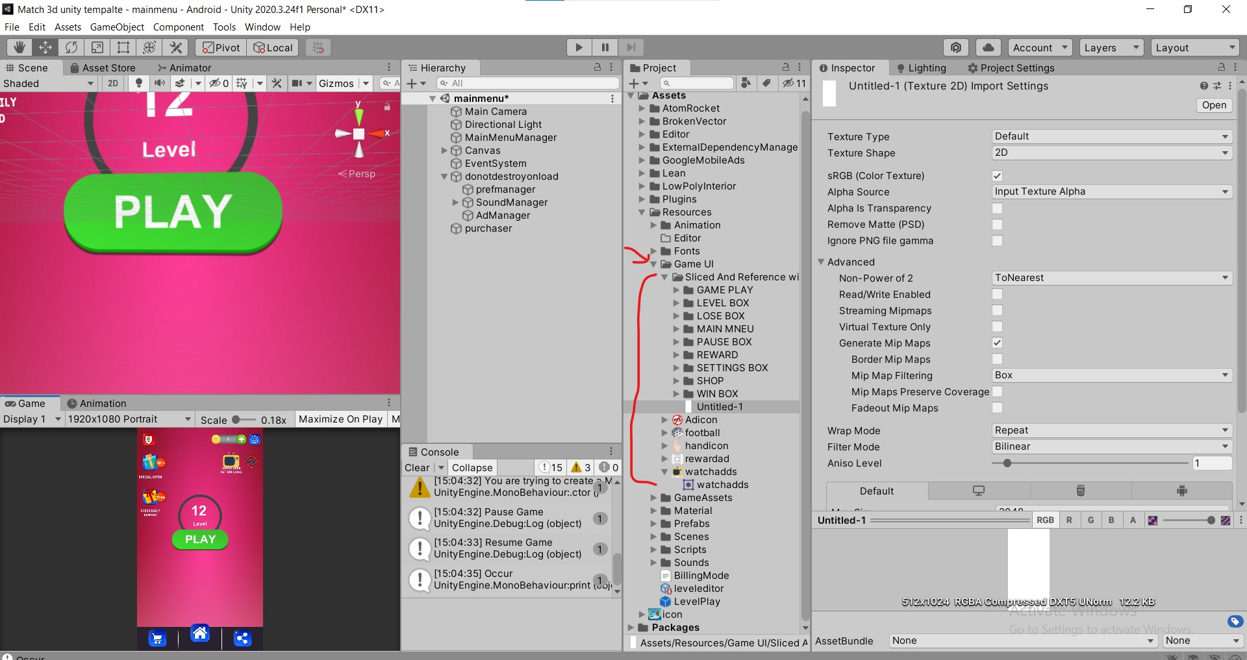

**How to Add Configure Objects**

**Video Tutorial link:**

**1.**Open gameplay scene

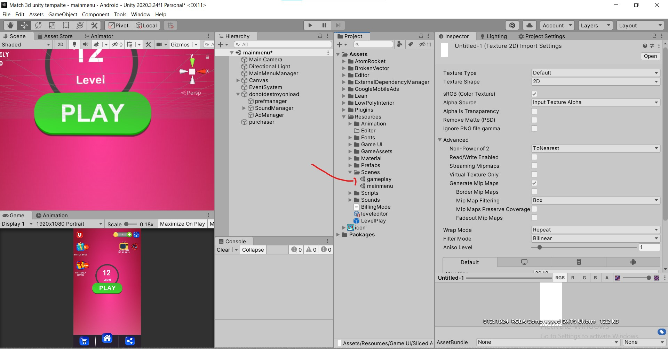

2.Drag or Import your 3d models In Project tab  
3.Drag and Drop your Object In CheckNewGameObject and Make their position Zero and Scale 1 like In the Screen

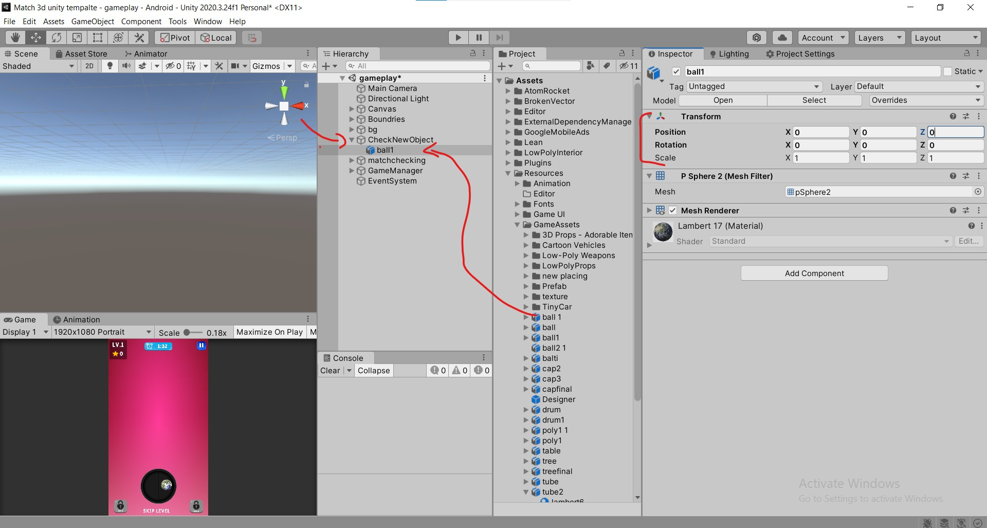

4.Adjust Object through Model ScaleFactor

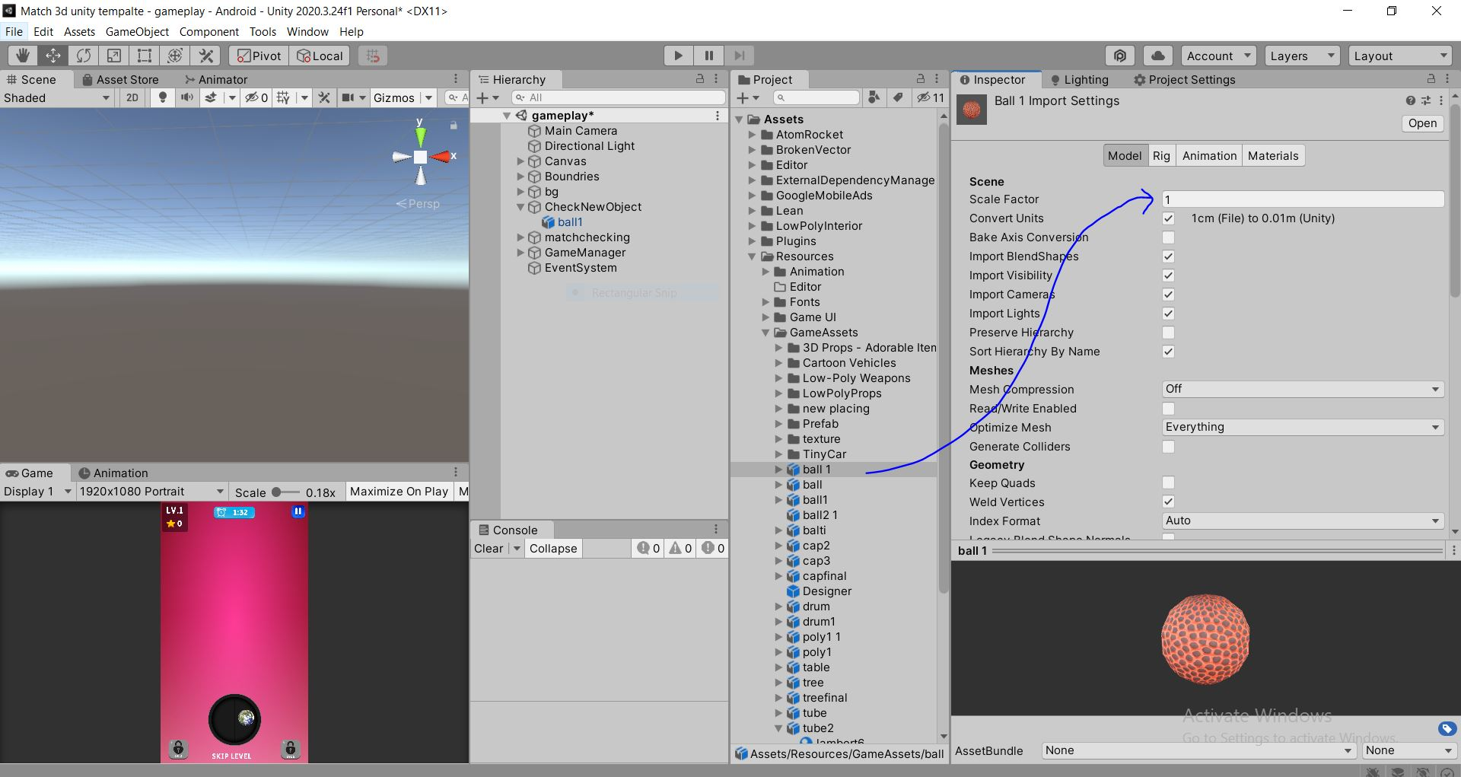

5.Add Componets on Gameobject  
-Mesh Collider,Item,Rigidbody   
6.You Can Set Rotation value of Object as you like after Object Placing

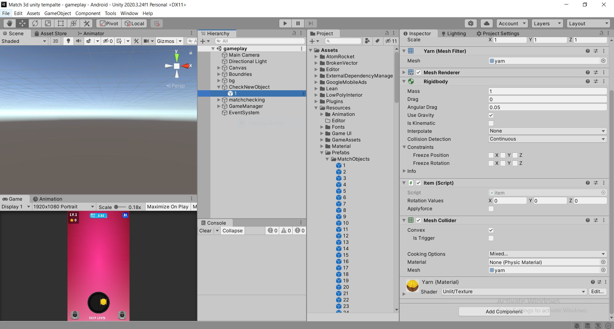

**How to Create New Levels**

**1.**Open Resources folder  
**2.**Click On Level Editor **3.**Give Level Name  
**4.**Give Total Minutes and Seconds   
**5.**Assign Number of Objects you want to Place In the Level



**Contact US:** [**ashstudioinc@gmail.com**](mailto:ashstudioinc@gmail.com)